1. SignUp page – note: account is already created, so the message popped up as error occurred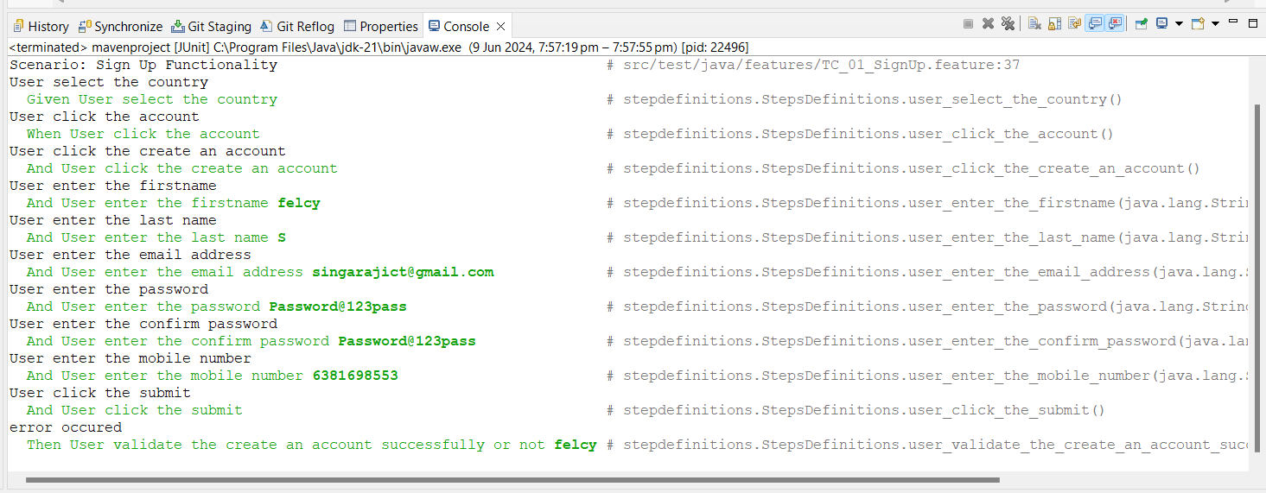
2. Verify URL

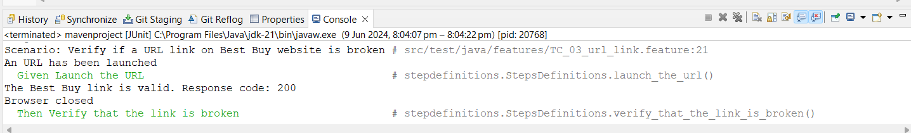

1. Validate the links

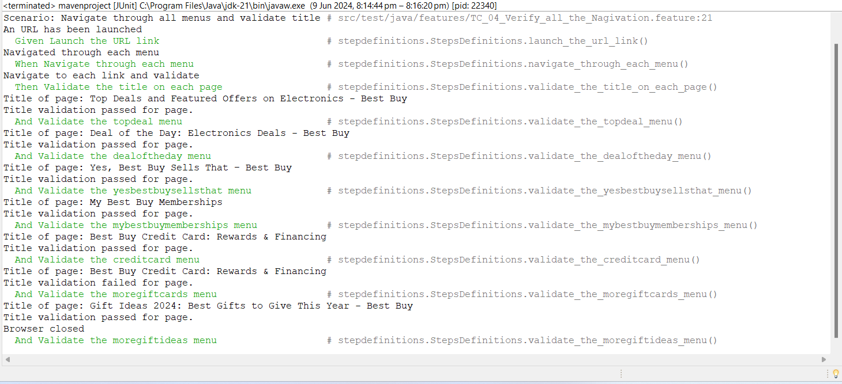

1. Bottom Links

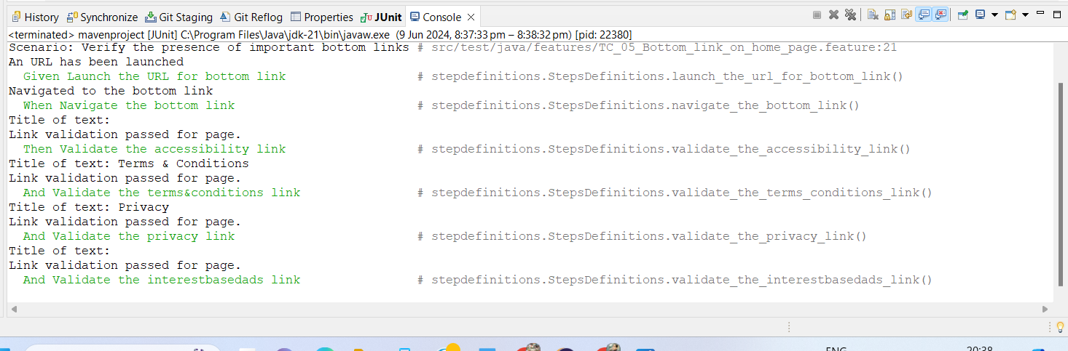

1. Search by Brands

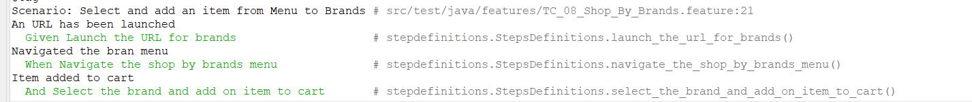

1. Search by department

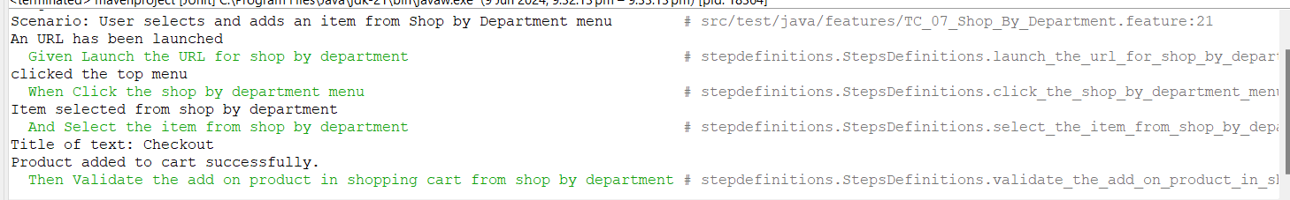

1. Checkout process

